1. Write a program that accepts user’s section, and display them back with the format “\*\*\* Section: *user’s section* \*\*\*”.

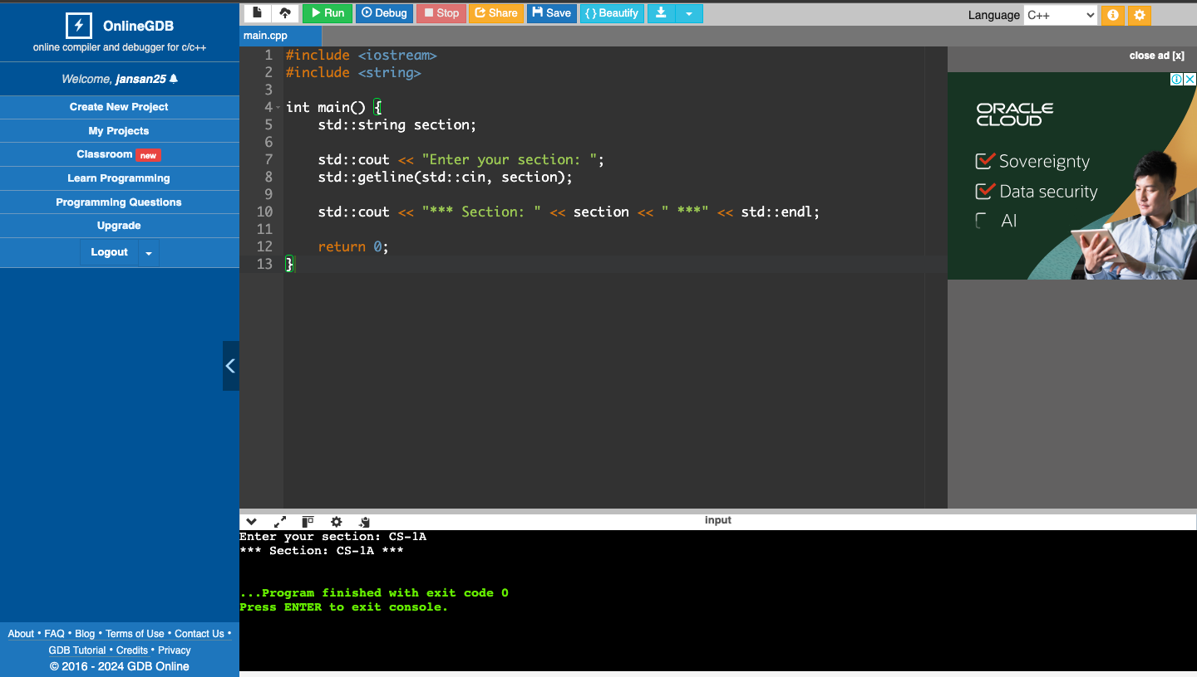

1. Write a program that accepts user’s daily budget and display the product of the daily budget and itself.

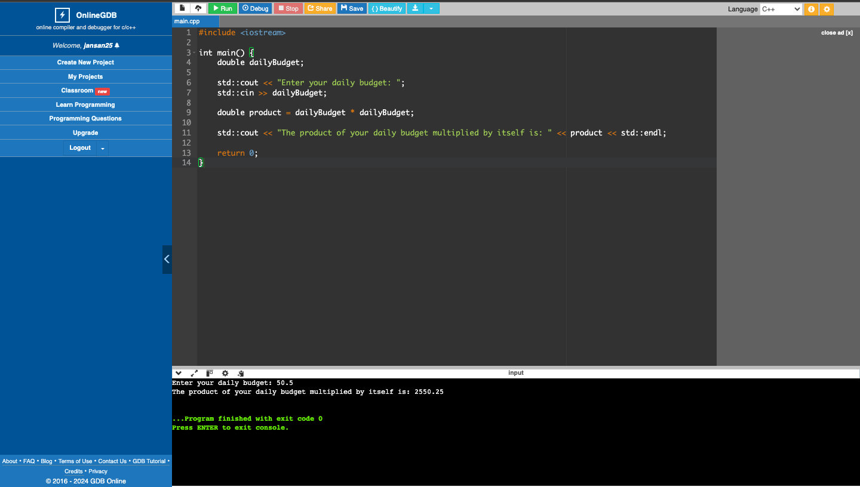

1. Write a program that accepts user’s name, password and address and display them back using the format “Hi, I am *user’s name*. I live at *user’s address*.”.

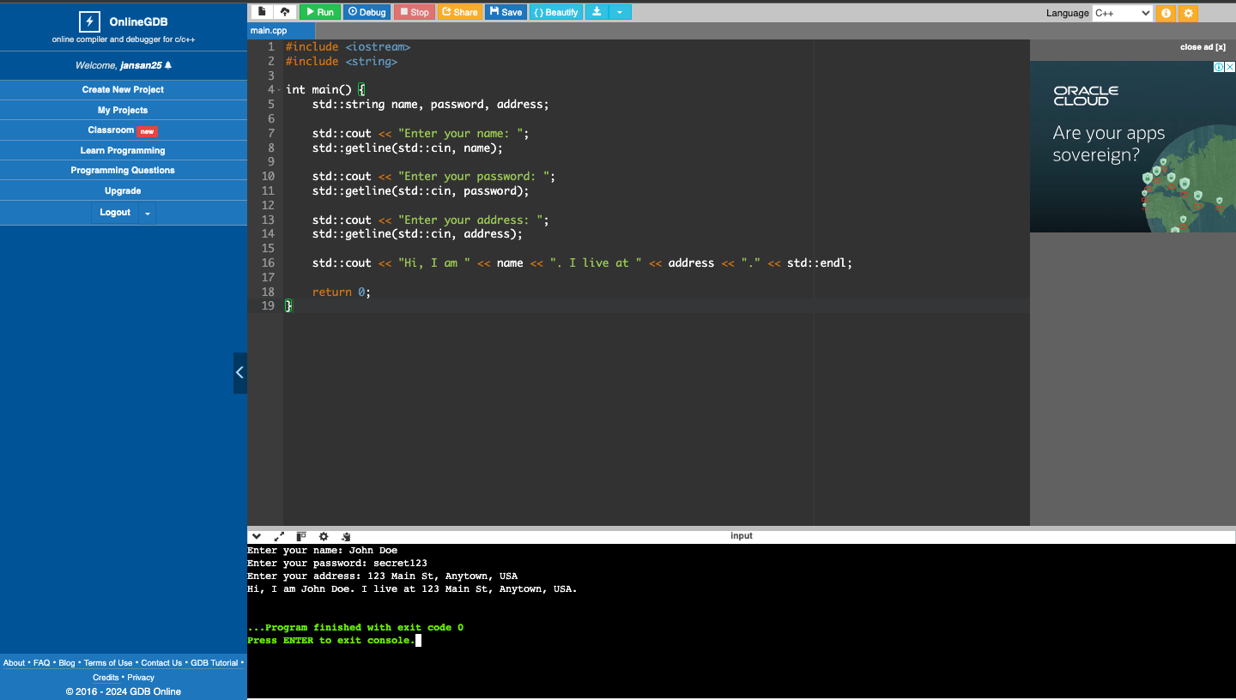

1. What can you conclude from this activity?

To accommodate whitespaces in the input, I utilized string variables in conjunction with the getline function. This approach allows the cin operation to capture the entire input, including any spaces, rather than stopping at the first whitespace encountered.